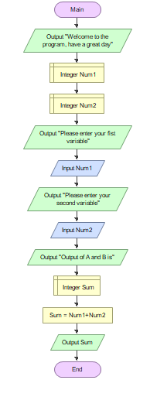

**Steps & Procedures:**

1. Start the flowchart
2. Write output
3. Declare Num1
4. Declare Num2
5. Write output
6. Input the value of Num1
7. Input the value of Num2
8. Write output
9. Declare Sum
10. Process formula of sum
11. Write output Sum
12. End the flowchart

**Flowcharting Symbols:**

**Start/End Flowchart SymbolStart/End Symbol**

**Input/Output Flowchart Symbol Input/output Symbol**

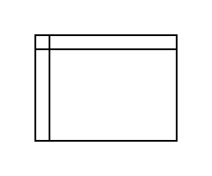**Declaration Symbol**

**Process Flowchart Symbol Process Symbol**

**Explanation:**

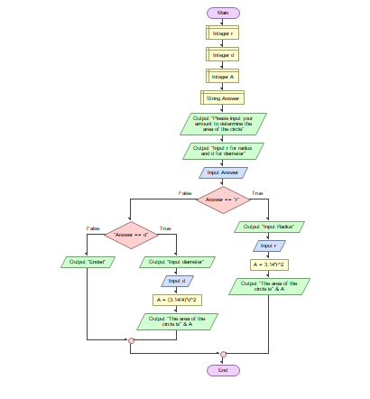

**Steps & Procedures:**

1. Declare Integer r
2. Declare integer d
3. Declare integer A
4. Declare String Answer
5. Write output
6. Write output
7. Input Answer
8. Ask if it is r or d?

If r

1. Write output
2. Input the value of r
3. Process formula of A
4. Write output of A

If d

9. Ask if it is d

If True

10. Write output

11. Input the value of d

12.Process formula of A

1. Write output of A

If False

10. Write output